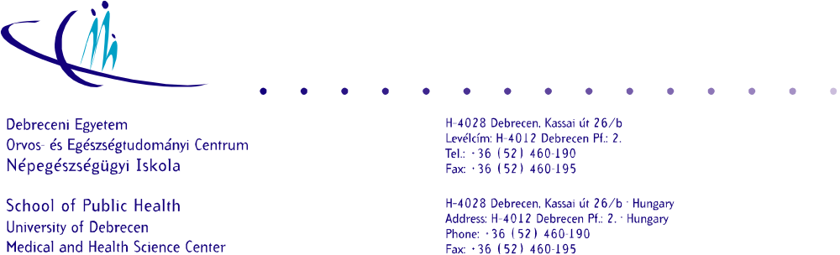
Basics of Epidemiology
December 22, 2016
MSC IN PUBLIC HEALTH

Name:
Result:

Choose the only correct answer!

1.
Which study has the least evidence producing power?
- Ecological study
- Cross-sectional study
- Case-control study
- Follow-up study

2.
Which study needs the biggest resources?
- Ecological study
- Cross-sectional study
- Case-control study
- Follow-up study

3.
Which study is insensitive to latency period of disease manifestation?
- Ecological study
- Cross-sectional study
- Case-control study
- Follow-up study

4.
Which study is sensitive to the recall bias?
  - Ecological study
  - Cross-sectional study
  - Case-control study
  - Follow-up study

5.
A population has been followed for a year (12 months). The yellow fever occurrence is detected. (white shading: healthy period; grey shading: active disease period; died: died of yellow fever; surviving yellow fever resulted in life long immunity) Answer the questions regarding to this situation! (If a ratio is calculated, then both the nominator and the denominator have to be given!

id | sex | months
id | sex | 1 | 2 | 3 | 4 | 5 | 6 | 7 | 8 | 9 | 10 | 11 | 12
1 | male
2 | male
3 | male
4 | male
5 | male
6 | male |  |  |  |  |  |  |  |  |  |  | died
7 | male
8 | male
9 | male
10 | male
11 | male
12 | male
13 | male
14 | male
15 | male
16 | female
17 | female
18 | female |  |  |  |  |  |  |  | died
19 | female
20 | female
21 | female
22 | female
23 | female
24 | female

Prevalence among females for the observed year:
= 4/9 or 4/8,5

Prevalence among males for the observed year:
=5/15 or 5/((15+14)/2)

Incidence among females:
3/

Incidence among males:

Incidence rate of females compared to males:

Cumulative incidence in the second half of the study period:
2/17 ➔ persons who developed the outcome/ the number of persons at risk

Point prevalence among females in the 6th month:
1/9

6.
The adult population living in a village is composed of 7599 persons (4220 females, 3379 males). Among them, 750 are patients with ischemic heart disease (377 females, 373 males). The 1255 female and 901 male healthy (ischemic heart disease free) adults were willing to participate in a colorectal cancer screening program. There were 168 female and 214 male participants with ischemic heart disease. Answer the questions regarding to this situation!

Proportion of screening participation among females living in the village:
- 33.0%
- 33.4%
- 33.7%
- 57.3%
- neither of them

Proportion of screening participation among females with ischemic heart disease living in the village:
- 33.0%
- 33.4%
- 33.7%
- 57.3%
- neither of them

Relative risk of screening participation among adults with ischemic heart disease living in the village compared to the healthy adults living in the village:
- 0.943
- 1.365
- 1.618
- 1.914
- neither of them

Relative risk of screening participation among healthy females compared to healthy males:
- 0.777
- 1.022
- 1.090
- 1.232
- neither of them

Is there significant difference between male and female healthy adults’ participation willingness?
- yes, there is significant difference; the males are more willing to participate
- yes, there is significant difference; the females are more willing to participate
- no, there is not significant difference, but the point estimation is lower for male willingness
- no, there is not significant difference, but the point estimation is higher for male willingness
- cannot be determined for the described situation

7.
The effectiveness of a new drug is investigated in the respect of improving the quality of life of patients (QoL) with an autoimmune disease. Data collection is carried out by cross-sectional method after 1 month of the beginning of drug trial. The following data were observed:

 | improved QoL | unchanged QoL
treated | 150 | 300
control | 400 | 900

Answer the questions regarding this situation!

What is the odds ratio for the presented situation?
- 0.875
- 0.909
- 1.091
- 1.125
- neither of them

The effectiveness of the drug had been reevaluated after 3 years. 60 patients in the treated group discontinued the treatment because of the side effects of the drug. 15 of them did not experience improved QoL before quitting treatment. All of the subjects of control group were collaborative during the whole study.

What was the observed odds ratio at the end of the 3rd year?
- 0.830
- 0.840
- 1.000
- 1.141
- neither of them

What is the tested drug in the respect of QoL improvement according to this study?
- risk factor
- protective factor
- neutral factor
- confounding factor

8.
The association between caffeine intake and osteoporotic hip fracture is studied by case-control design. There were 465 hip fractured patients (254 exposed to high caffeine intake). The number of study participants was 14288 (6433 exposed to high caffeine intake).
Carry out the statistical evaluation; and interpret the results keeping in mind that the calcium intake which is in negative coincidence with caffeine intake was not included in the model!

9.
How can you interpret the following statistical results?

b= 2.4 [95% confidence interval: 1.8 – 3.0]

RR= 0.88 [95% confidence interval: 0.65 – 1.11]

OR= 0.97 [95% confidence interval: 0.95 – 0.99]

CI= 0.25/5years [95% confidence interval: 0.20 – 0.30]

ID= 0.1/person-years [95% confidence interval: 0.05 – 0.15]

b – linear regression coefficient
RR – rate ratio
OR – odds ratio
CI - cumulative incidence
ID – incidence density

10.

The influence of life-style modification is studied. The main interest is whether the increase of physical inactivity by a special training program can improve the clinical status of diabetic patients who are free of manifested diabetes complications, and who do not need insulin administration. All the patients selected for the study are treated by OAD (oral antidiabetic drug). The study model defines the age, sex, education, change of BMI, and change of mono/di-saccharides intake as confounding factors.

The collected data are summarized in the data exam-A 20161222.xlsx file. The coding for the table:
age: year
sex: 1 – male; 2 - female
education: 0 – less than primary; 1 – primary; 2 – secondary; 3 - tertiary
change of BMI: 0 – not changed; 1 – significant decrease
change of mono/di-sacharides intake: 0 – not changed; 1 - significant decrease
change of inactivity: 0 – not changed; 1 – significant increase
change of required OAD dosage: 0 – not changed; 1 – significant decrease

Answer the study question, and draw the conclusion!

11.
Study the attached paper and answer the following questions!

(György Jermendy, Judit Nádas, Endre Szigethy, György Széles, Attila Nagy, Tibor Hídvégi, György Paragh, Róza Ádány: Prevalence Rate of Diabetes Mellitus and Impaired Fasting Glycemia in Hungary: Crosssectional Study on Nationally Representative Sample of People Aged 20-69 Years. Croat Med J. 2010; 51: 151-6)

How is the public health importance described?

What is the study question?

What is the studied model?

What is the statistical inference?

Is there measurement bias in the respect of exposure?

Is there measurement bias in the respect of outcome?

Is there selection bias in the study?

Are there non-controlled confounding factors in the study?

What is the answer to the research question?

What is the practical conclusion?

